Vanity area in a Yacht Club stateroom that can be converted to a Commodore Suite

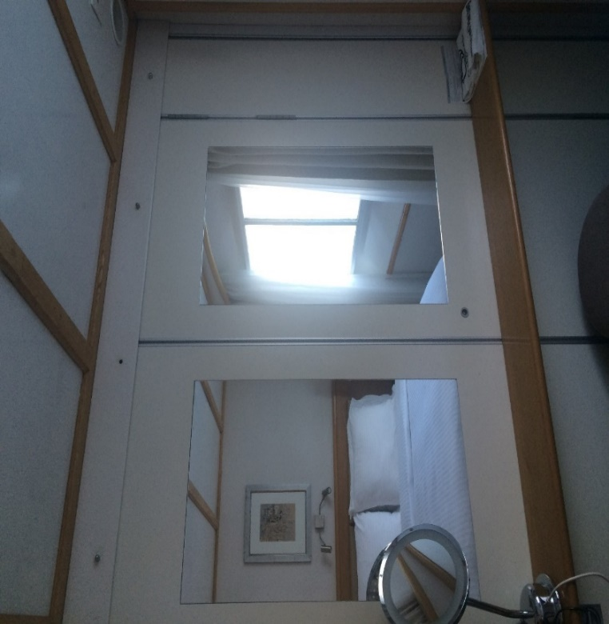

Wall removed between staterooms 303 & 305 (the make-up mirror is placed on the writing desk when the 2 staterooms are converted to a Commodore Suite)

